U04692 BSc Project

Project Plan Report

Project Title | Mechanical Radial Error Correction
Module Number | UO4692
Student Number | 07089704
Name | Marc Hudson
Supervisor | Khaled Hayatleh
Date | 7th October 2013

Department of Mechanical Engineering and Mathematical Sciences
2013-2014
Title: Mechanical Radial Error Correction
A versatile control system which can be used to accurately position a shaft using feedback and error correction.
- INTRODUCTION
This is a project in which the technologies behind the methods used to correct radial position error will be explored, evaluated and put into practice. Error correction is an important part of any closed-loop system; it is used frequently in many electro-mechanical systems. To outline the purpose and use of error correction; it is used to ensure a required output will match a user, or application defined reference. This is done through comparing the system output with the reference, and adjusting until the error between the reference and output is corrected. In short, the system will automatically adjust to the desired position.
Amongst other things, applications of such a technology are commonly found in stepper motor control, robotics, avionics, and things like temperature controls. A basic, yet well-known application of error correction would be in a household thermostat. In this example the house is being heated until the user defined temperature is met, at which point the boiler clicks off. This is achieved through a closed loop system which is continually checking the temperature against what the user desired in the first place.
This project specifically will focus on the rotational control of a shaft in a particular application. For this, the same theory is applied regarding the correction of error until a desired position is achieved. This time however, in order to achieve the correct position, the system will be relying on inputs of a different nature to those mentioned in previous examples. For this project, the system will be making adjustments according to either frequencies picked up by a microphone, through vibration or from a direct signal from the instrument.
The project will be to make a unique automatic tuner for a guitar where user input is not required. A system which takes the frequencies produced by playing a guitar string, makes an assumption of which pitch the string is supposed to be, and rotates the shaft of the machine head (tuning knob) until the desired pitch is met.
This kind of closed loop system is often referred to as PMC, or Programmable Motion control. As Dr O’neil states (1998, pp2):
PMC is defined as the application of programmable hardware and software (in conjunction with input sensory devices, actuators and other feedback devices) for the control of one or more linear or rotary motions.

- OVERALL AIM AND OBJECTIVES OF THE PROJECT

The objective of the project is to design and build an electro-mechanical system which can automatically tune an electric guitar. For now this is the main aim, however, as the project goes on, it’s expected that further features will be implemented into the project in order to increase functionality and ease of use.
SMART Objectives
Specific:
The project will succeed in making the process of tuning a guitar easier AND quicker than tuning each machine head by hand. And will be to a required standard of accuracy which can be measured.
Measurable:
The performance of the product can be observed and measured. The tuner must be able to rotate the shaft until the reference pitch is achieved. This will be later compared with human perception and explained as to what accuracy is considered acceptable by the end user. According to C.R.Nave (2013), the human ear is able to detect changes in frequency as little as 1hz. Extensive testing will need to take place regarding this matter before riding the product design specification.
Achievable:
With the resources available from the university and the amount of time allocated. This project is achievable and will be completed within the set time.
Relevant:
The relevance of this project is without question. The technology, although available, is rarely applied to this application. Other products that attempt this are unreliable and professionals in the industry refer back to manual tuning as a result.
Time-bound:
This project will be completed by 23rd April 2014. The product itself and all the documentation will be completed and submitted by this date.

- BRIEF LITERATURE REVIEW
In order for any project to be comprehensive in its result, it’s important to review previous literature on the topic. The following textbooks have been reviewed for information on the topic of mechanical radial error correction:

Djaferis, Theodore Euclid. (1998). Automatic control: the power of feedback using MATLAB. Boston : PWS Publishing.

Phillips, Charles L; Harbor, Royce D.(2000). Feedback control systems. 4th Edition. London : Prentice-Hall

- Dorf, Richard C. (Richard Carl). (1998). Modern control systems. 8th ed. Harlow : Addison-Wesley
Further to this, there are two previous projects completed at Oxford Brookes University, which discuss the uses of both DC motors and the programming of an Arduino board. For this project, the initial prototypes will be made using an Arduino, so this literature is important for research.
- Rizwan, Mohammad. (2009). Controlling air driven motor with Arduino board. BEng Thesis. Oxford Brookes university.

- Newton, James Leonard. (2012). Controlling a brushless motor. BSc Thesis. Oxford Brookes University.
In addition to books and previous student projects from the university, It’s also important to review online journals for relevant information. As this project is electro-mechanical, both the circuitry / programming side and the motor side need to be researched. Below are 3 engineering journals, and in addition, one technical paper on motion control.
- Ziegler, J.G., and Nichols, N.B.(1942), Transactions of the American Society of Mechanical Engineers (ASME). Optimum Settings for Automatic Controllers v. 64, pp. 759-768.
- Nehal M. Elsodany, Sohair F. Rezeka, Noman A. Maharem. (2010). Adaptive PID control of a stepper motor driving a flexible rotor. Alexandria Engineering Journal. 50. Pp.127-136

- Adamu Murtala Zungeru and Mahmud Shehu Ahmed. (2012). Development of a duel heater control system. Vol.2, No.4. pp 16-23.

Additional technical paper

- Dr. Stephen J. O’Neil. (1998). Motion control handbook. pp. 1-38.
4.0 INDUSTRIAL AND RESEARCH RELEVANCE
In choosing this project, it was of utmost importance to find something for which there was a genuine need in the industry. This is for two reasons; first of which is that designing and manufacturing such product can assist in the daily work of technicians in the industry, secondly, the project could become a viable product to put on the market in the future.
The project itself is to explore the technology involved in accurately controlling rotation of a shaft. The technology behind error correction using closed loop systems is already commonly used in a multitude of applications. However, this application is more unique as the aim of this project is to produce an automatic guitar tuner. From Internet research, there are few professionally produced units that have the ability to tune a guitar automatically. From research into these products, they’re not without their pitfalls. The aim of this project is to design and manufacture a simplistic, ergonomic and accurate guitar tuner, which is easier to use than those on the market.
From having 3 years in the industry it can be said that the necessity of this product is without question. At the top-end of the industry when artists business is lucrative and they are performing regularly, it is considered standard practice to employ a technician who is responsible for keeping all instruments in tune and in working order. That being said, depending on the success of the performer in question, they can have upwards of 10 technicians depending on the complexity of the stage production and technology used. To put the scope of the work involved in perspective, even for a lower-budget stage production, there may be 6 guitar changes in one performance. Each time, the guitar needs to be tuned. Further to this, each time a guitar string breaks or the guitar needs to be re-strung; all the strings need to be tuned. Most guitars have 6 strings, so the amount of time spent maintaining the tuning quickly becomes a difficulty.
In the case where there is for example 1 or 2 technicians, the necessity of this product really becomes apparent. An automatic tuner not only will save the technician significant amounts of time, but it will also eliminate human error in the tuning process.
Industry standard guitar tuners range from having a 6.3mm jack input (used for Guitars, Microphones, Keyboards, Effects Pedals, Professional Headphones, Mixing Consoles, Patch Bays, etc.) to having a clip-on capability to detect string vibration from the body of the guitar. These tuners typically display a range of frequencies in which the string pitch should be within. The task of the technician is to look at the screen and manually rotate the machine heads of the guitar until the pitch is achieved. Understandably, this process can be time consuming and the process is exposed to a high likelihood of human error. The project when in it’s completed state will eliminate these difficulties and make the job easier for technicians and musicians alike.

- ASSESSMENT OF THE RESOURCES NEEDED
- Arduino board for prototyping
- Prototype board
- Semiconductor components
- Cables (for instrument and for circuit board)
- Programmable I.C for final product
- Stepper Motor
- Power supply
- MATLAB or SIMULINK software
- Expert advice from lab technicians
- Access to the tools required for making a prototype
- Access to the laboratory to carry out the work
- Access to a CAD package to design the housing
Potential extra requirements
- Access to a 3d printing facility to make prototype housing

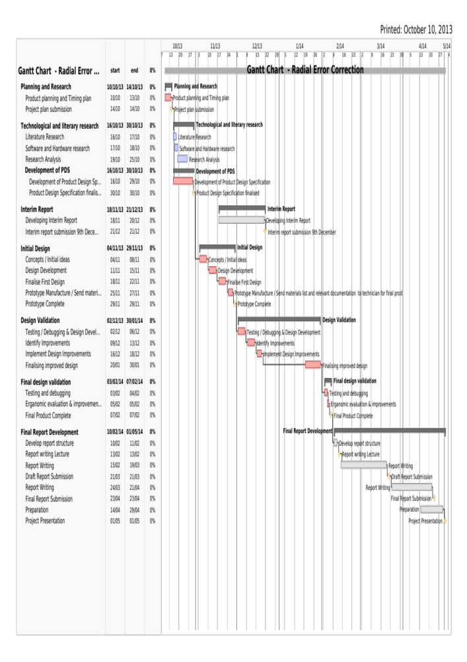

7.0 SUMMARY OF THE PROJECT PLAN

In summary, as long as the project plan is followed, the project will be completed well within the time constraints and the project will meet all aspects of the Product Design Specification. All of the technology is available and the resources required are within the confines of the university so it should be a simple task to acquire everything needed to manufacture both the prototype version of the project, and later, the final design. Extra time was allocated in the ‘design validation’ stage in order to correct bugs in the software and hardware. It’s important when reviewing progress to allow extra time in case extra developments can be made that may not have been planned in the beginning. I.e. from spending 4 days in the laboratory, extra functions could be implemented, making the product work in a more efficient way / having more functionality.

Also included in the project plan is the detail regarding the project write-up. Although it’s not related to the manufacture of the project, it’s important not to lose sight of the fact that the documentation is almost more important than the physical end product. This is because the journey from the concept stage through all the inevitable problems to the end result will make for useful reading if any future student / engineer wishes to review this project to help with something of their own.

The relevance of the project has been established and the need for such a device in the industry is apparent. Therefore every effort will be made for the project to be well-engineered, functional, easy to use and erganomic for the end user. The literature search will prove it’s worth upon researching both the methods used for error correction, and on the mechanical side, what is torque is required to tune the machine head of any guitar. From initial reading, it’s clear this project is going to be very in-depth with a lot of challenges to overcome.

8.0 LIST OF REFERENCES

Djaferis, Theodore Euclid. (1998). Automatic control: the power of feedback using MATLAB. Boston : PWS Publishing.

Phillips, Charles L; Harbor, Royce D.(2000). Feedback control systems. 4th Edition. London : Prentice-Hall

- Dorf, Richard C. (Richard Carl). (1998). Modern control systems. 8th ed. Harlow : Addison-Wesley

- Rizwan, Mohammad. (2009). Controlling air driven motor with Arduino board. BEng Thesis. Oxford Brookes university.

- Newton, James Leonard. (2012). Controlling a brushless motor. BSc Thesis. Oxford Brookes University.

- Ziegler, J.G, and Nichols, N.B.(1942), Transactions of the American Society of Mechanical Engineers (ASME). Optimum Settings for Automatic Controllers v. 64, pp. 759-768.
- Nehal M. Elsodany, Sohair F. Rezeka, Noman A. Maharem. (2010). Adaptive PID control of a stepper motor driving a flexible rotor. Alexandria Engineering Journal. 50. Pp.127-136

- Adamu Murtala Zungeru and Mahmud Shehu Ahmed. (2012). Development of a duel heater control system. Vol.2, No.4. pp 16-23.
- O’Neil. S (1998). Motion control handbook. pp. 1-38.
- Nave C.R (2013) Hyperphysics.

(Please follow the Brookes Harvard standard reference citation method. See: http://www.brookes.ac.uk/library/resources/harvard.pdf for more information on referencing).

Note:
- Please check the assessment scheme while you are preparing your project plan. You can remove the assessment scheme from this template before you submit your project plan.
- Expected length of the project plan- approx 7 pages
- Please submit project plan as a booklet/ properly stapled/ comb bound report
- Appendix -A
Project plan Assessment Scheme.

Assessment | Weight | Marks awarded in % | Justification
Content  - Overall aim and objectives are stated clearly  - Background to the project  - Introduction of the subject area  - Industrial and research relevance  - Brief Literature Review using appropriate resources  - Assessment of the resources needed  - Time Plan and Gantt Chart  - List of references | 0.20
Time Plan and Gantt Chart  - Objectives and clearly stated milestones included  - Detailed plan of activities for each task stated  - Reasonable time allocation for each task  - Gantt chart has a clear legend. | 0.45
Clarity of Outcome  - Clarity of aim and objectives  - Objectives are SMART  - Clarity of expected outcomes | 0.25
Presentation  - Project plan report is concise, easy to read and follow  - Tabular presentation of data where necessary and applicable  - Graphical presentation for giving clarity where applicable  - Use of references and implementation of Harvard referencing scheme | 0.10

Suggested Marking Scheme | Less than 40 % | Unsatisfactory | F
Suggested Marking Scheme | 40-49 | Below average | 3
Suggested Marking Scheme | 50-59 | Satisfactory | 2:2
Suggested Marking Scheme | 60-69 | Good | 2:1
Suggested Marking Scheme | Above | Outstanding | 1

